

**UNIVERSITY OF PETROLEUM & ENERGY STUDIES**

**Dehradun**

**CONTINOUS INTEGRATION**

**AND**

**CONTINOUS DELIVERY**

**Name: Aakarshit Agarwal**

**Course: B. TECH CSE DevOps (2018-22)**

**Roll no.: R171218001**

**Sapid: 500067782**

**Experiment-10**

**Jenkins Integration with Jenkins**

**Step-1:** Start and login to Jenkins

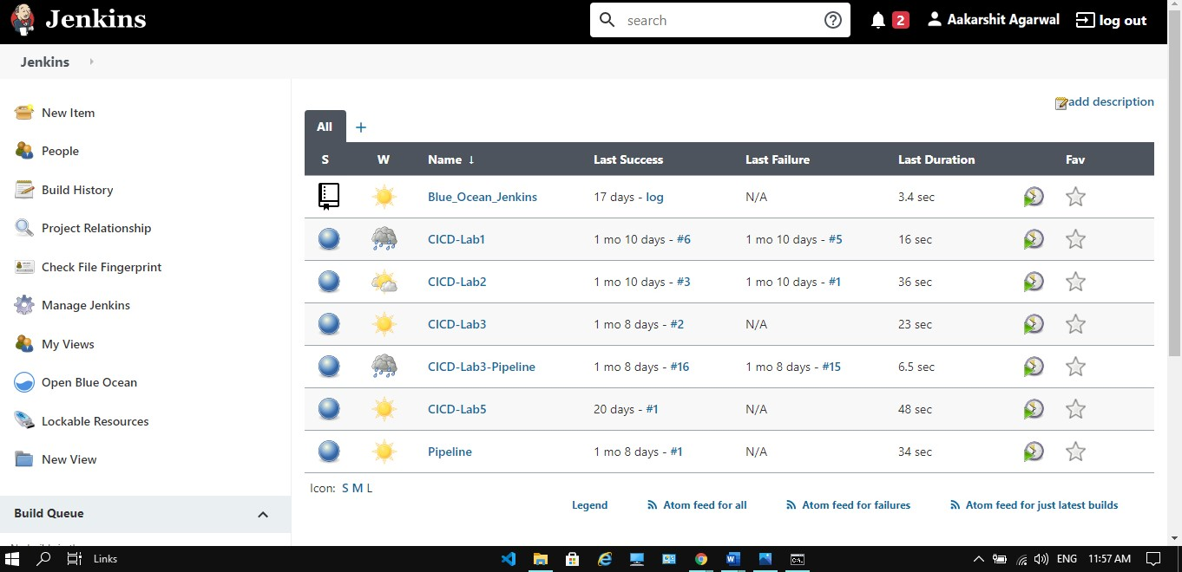

**Step-2:** Install nexus plugin

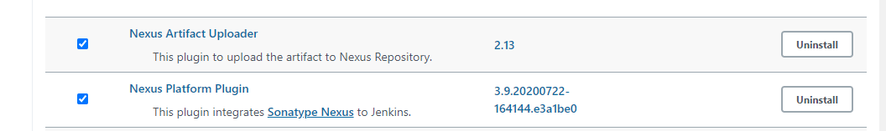

**Step-3:** Then go to global tool configuration and provide JDK 8 path

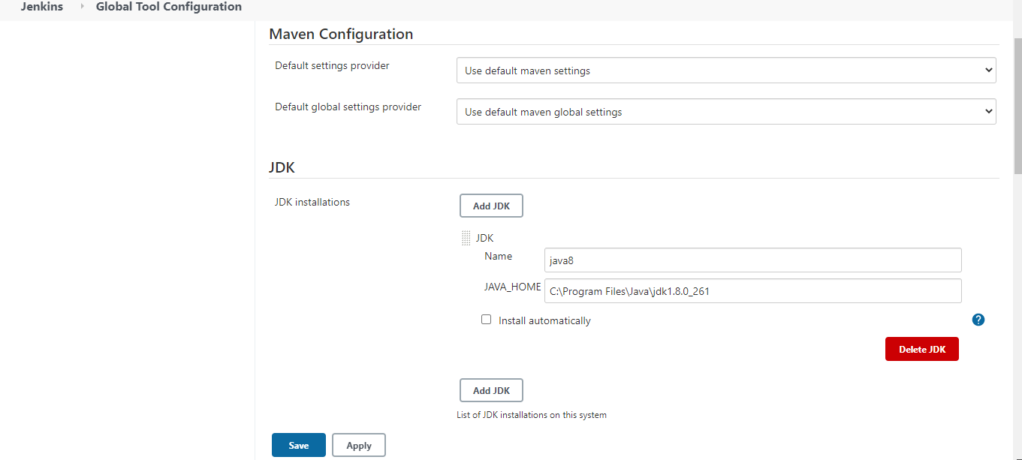

**Step-4:** Provide Sonatype nexus details in Configure System

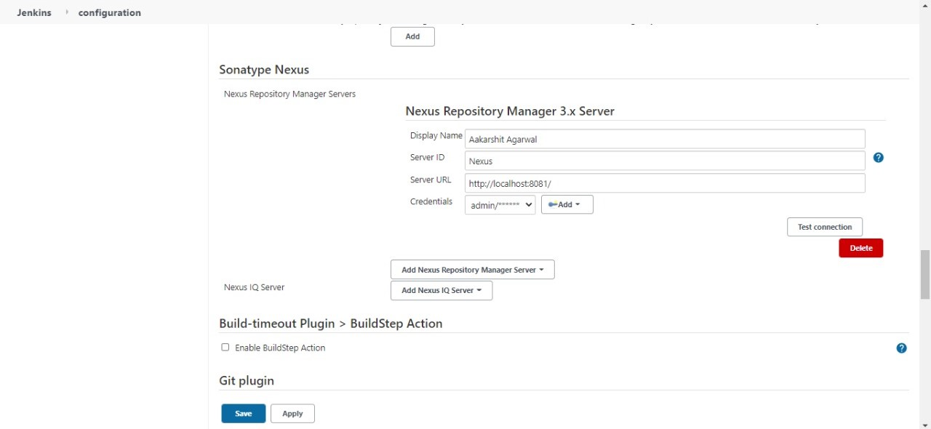

**Step-5:** Make a new Project and provide the details.

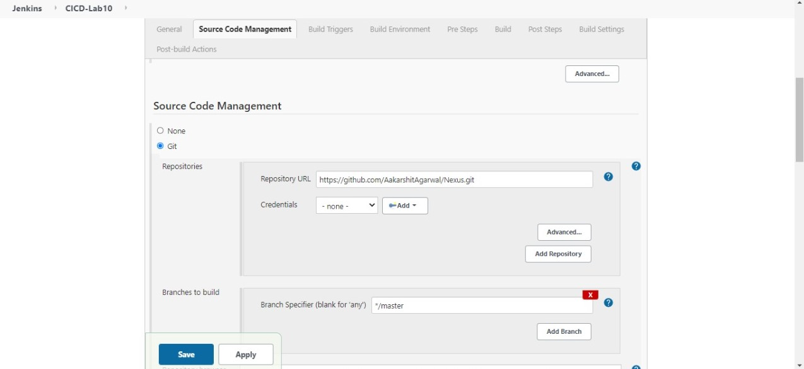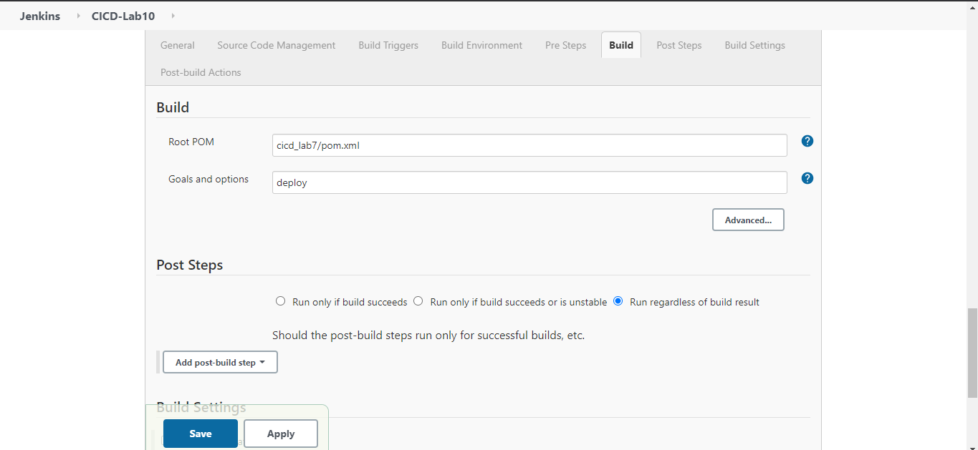

**Step-6:** Build your Project

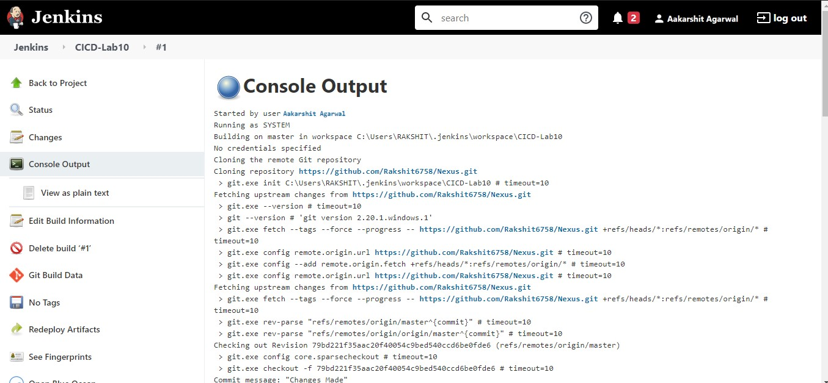

**Step-7:** Check nexus for build artifact

